

WINDOWS PRACTICAL TEST REVISION

Name:  Zara Teo | Admin No. 194123U | Group:  2
Name:  Zara Teo | Seat/PC No. 21

INSTRUCTION:

- If you need to create any files or folders, create them in the server’s (VM) C:\ drive unless the question states otherwise. Do not create them anywhere else.
- You must copy the screen output and paste it into the text box for marking. You can use the snipping or other tool to do this.
- All tasks are performed on the Windows Server. If the Windows Client need to be accessed, it shall be stated.
- Save the file as pdf format and submit into Blackboard in Week 15 Folder.

Tasks:

1. (a) Create a new OU (Organizational Unit) named AppleOU under frontier.net.

(b) Create a Group named Sales INSIDE AppleOU. Configure the group as Global and Security type.

(c) Create the User Accounts listed in Table 1 below INSIDE AppleOU. Add the user as member of the Sales group.

When you create the user account, the names in the User Account column are the login name. Set the password as Pa$$w0rd for all accounts. Disable “User must change password at next logon”.

Member of | User Account (login name)
Sales Group | Alex
Sales Group | Betty
Table 1
[Practical 1(d), 2A]

Use Active Directory Users and Computes to display the OU, group and members below:
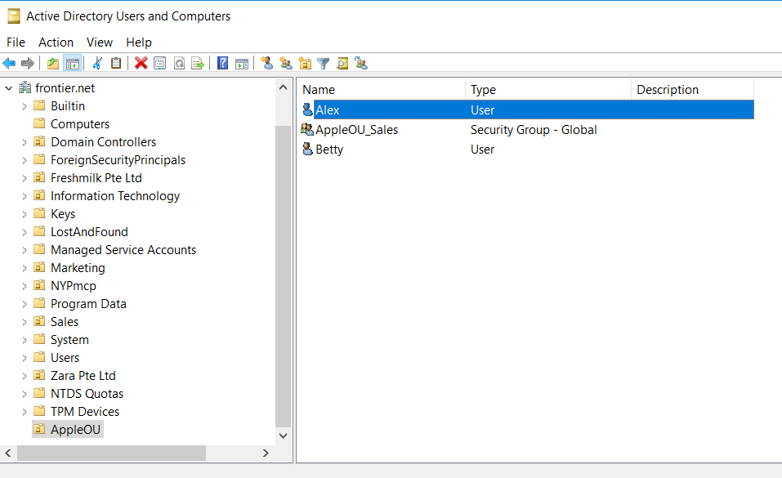

Show that Alex and Betty are members of Sales group.
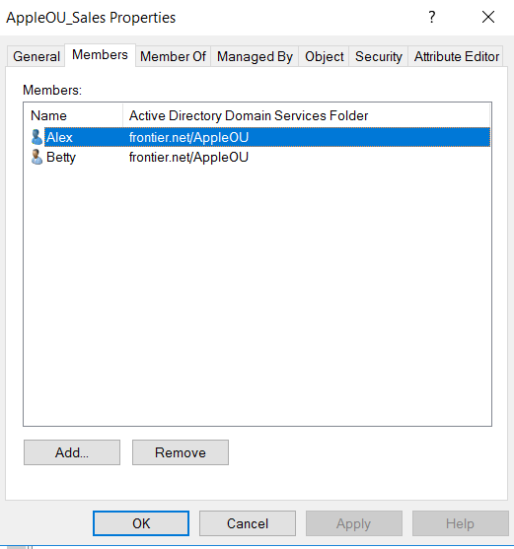

2. (a) Create a RAID 1 of 5GB. Add hard disks if necessary. Do NOT use Disk 0 which contains the C: drive. Format the Raid 1 as NTFS and set the volume name as Raid1 and the Drive as E: (Note: Revise Raid 0 and 5 too)

[Practical 3]

Use disk management to show that the Raid 1 is created.

3. Delegate the control Reset user passwords and force password change at next logon to Betty account.

[Practical 5A]

Display the screen to show that Betty has been assigned the delegation.
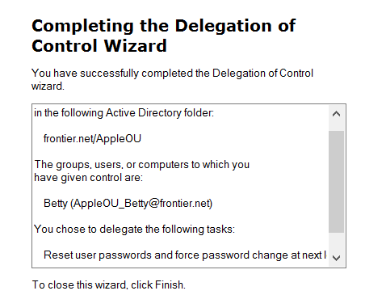
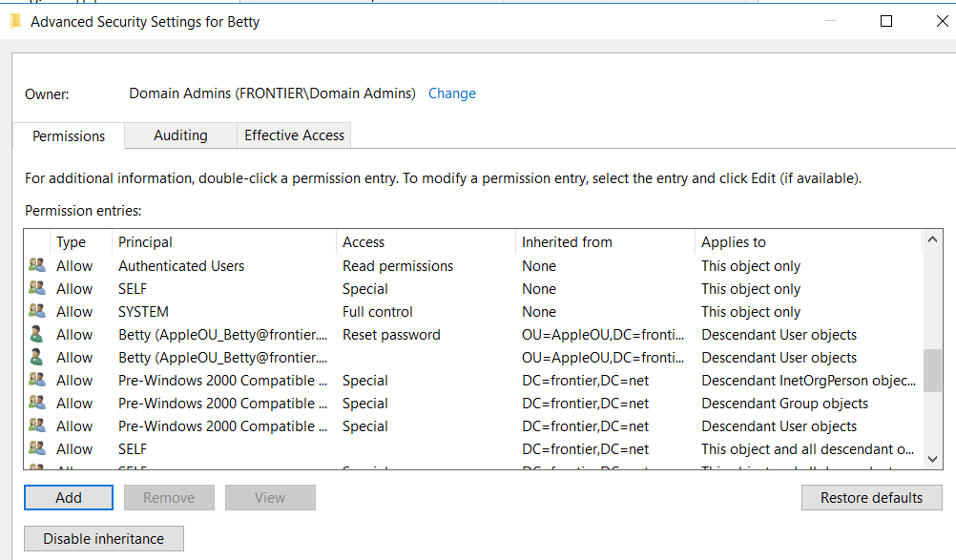

4. (a) Configure a shared folder for the Sales group on the server NYP-DC1 with the following settings:
- create a folder in (VM) C:\ drive called Allowances
- set the shared permissions as: remove Everyone group; set Sales group to allow Change and Read
- Hide the shared folder from the network discovery.

[Practical 4A]

Display the output to show the permission of the shared folder and that it is hidden from the network.
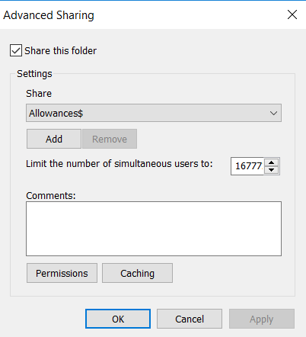
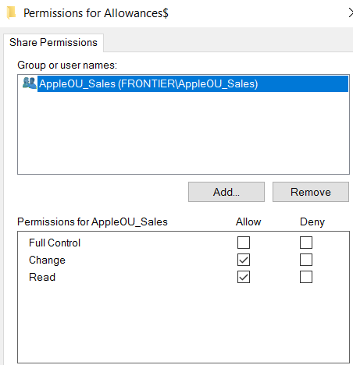

(b) Login to NYP-CL1 as Alex and map to the Allowances shared folder in the Windows/File Explorer as M drive. Note the client NYP-CL1 may not be joined to the domain yet.

Display the file explorer to show that Alex has mapped to the shared folder as M drive.
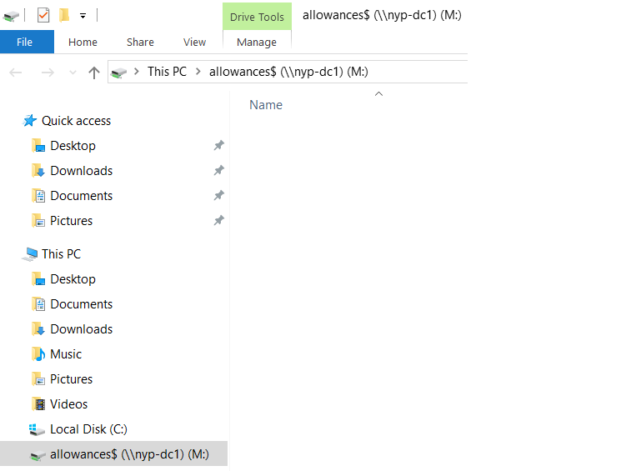

5. (a) Use Disk Quota to limit each user to 5 GB of data on the NYP-DC1 C: drive. Users will get a warning message when files storage reaches 3 GB. Prevent users from writing to the disk once the limit is exceeded.

[Practical 4B]

Display the disk quota configuration.
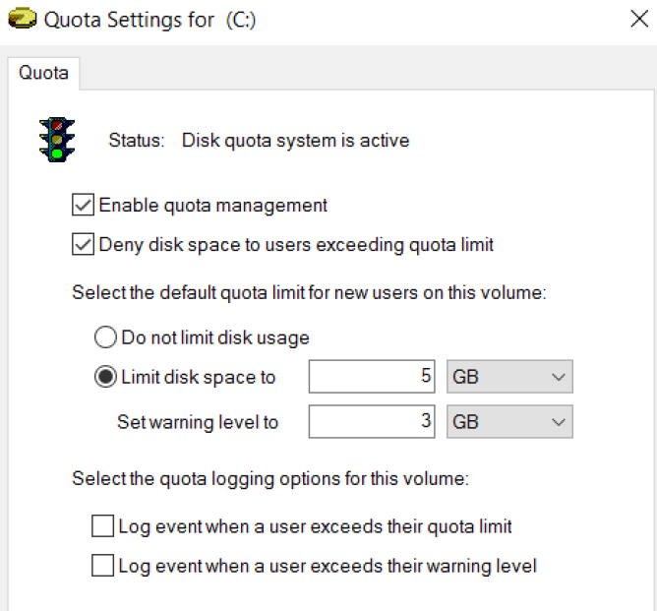

(b) Create a folder in C:\ named Topsecret and encrypt it.

[Practical 4B]

Show Topsecret is encrypted via its properties.
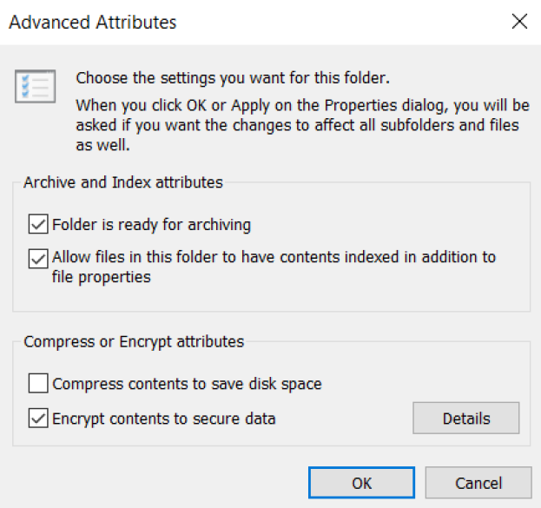

6. (b) Create a group policy called “No Recycle bin” in the Group Policy Objects folder. This policy removes the recycle bin from users’ desktop. Link the policy to AppleOU.

[Practical 2B]

Show that the policy is in the Group Policy Objects folder.
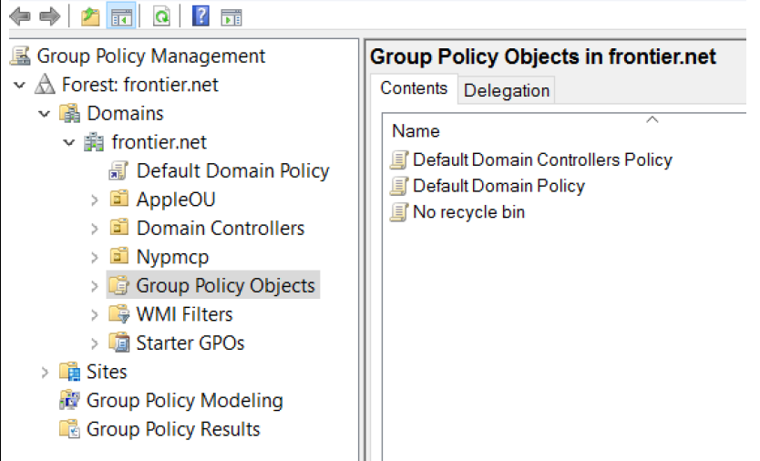

Show that the policy is linked to AppleOU OU.
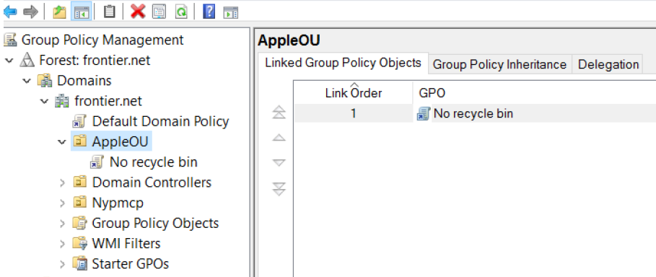

Show the “No recycle bin” policy configuration.
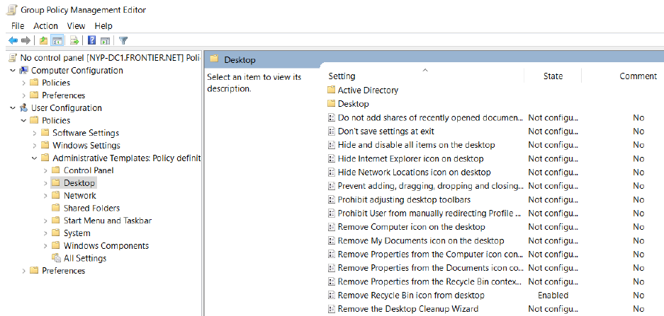

7. Configure a Roaming profile for Alex. Create any additional files or folders for this question in (VM) C:\ drive. Test the roaming profile either by using the Windows Client or using the Windows Server.

[Practical 1(d)]

Display the screen to show Alex’s roaming profile status.
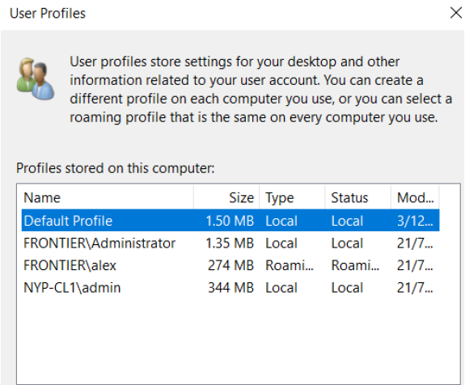

8. Configure the Windows Server to have remote access. Display the screen to show that remote access has been activated.

[Practical 5A]

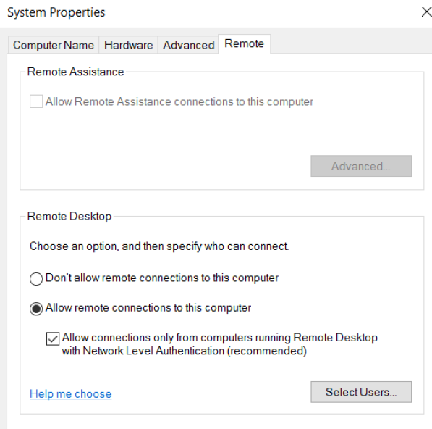

9. Configure if necessary and show that the server network configuration is set to the following:
IP address = 10.0.0.2
Network mask = 255.0.0.0
DNS = 10.0.0.2
You can use any method to do this.

[Practical 1b]
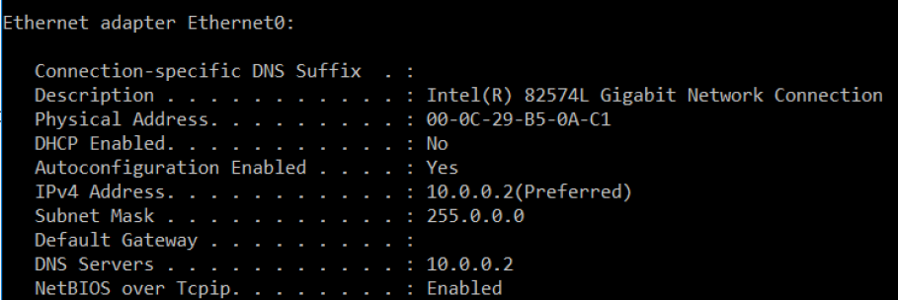

10. Add a new hard disk of 10 GB. Create the following volumes on it:
(a) A simple volume of 2GB formatted as FAT32. Volume name is fat32. Any drive letter.
(b) A simple volume of 2GB formatted as ReFS. Volume name is refs. Any drive letter.
(c) A simple volume of 2GB formatted as NTFS. Mount it to a folder named MountEverest in C:\ drive. The volume name is Mounted.

[Practical 3]

Use disk management to display the above results.
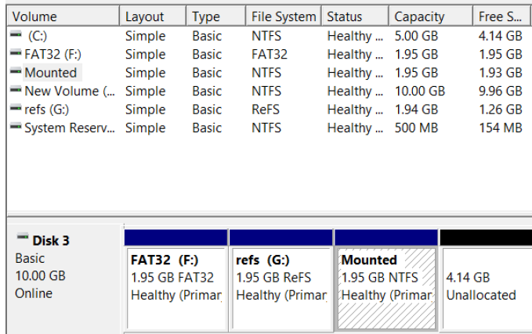

Show the mounted drive details using the file explorer:
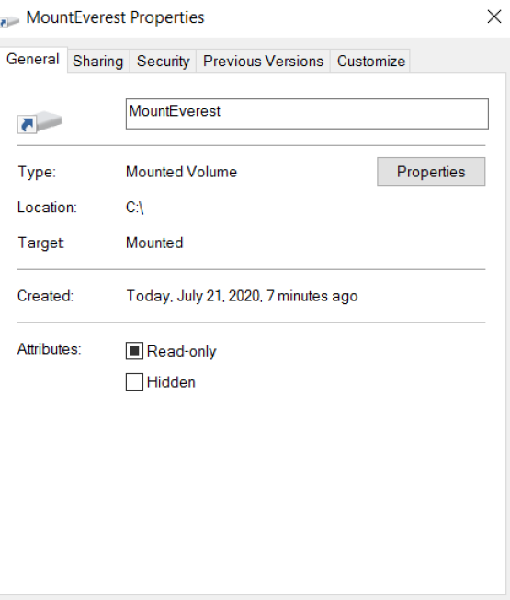

11. Set the password policy for EVERYONE in the domain as follows:
(a) Password must change every 30 days (Maximum password age)
(b) Minimum password length = 10 characters
The other password settings can keep the default settings.

[Practical 6A]

Use Group Policy Management to display the password policy settings.

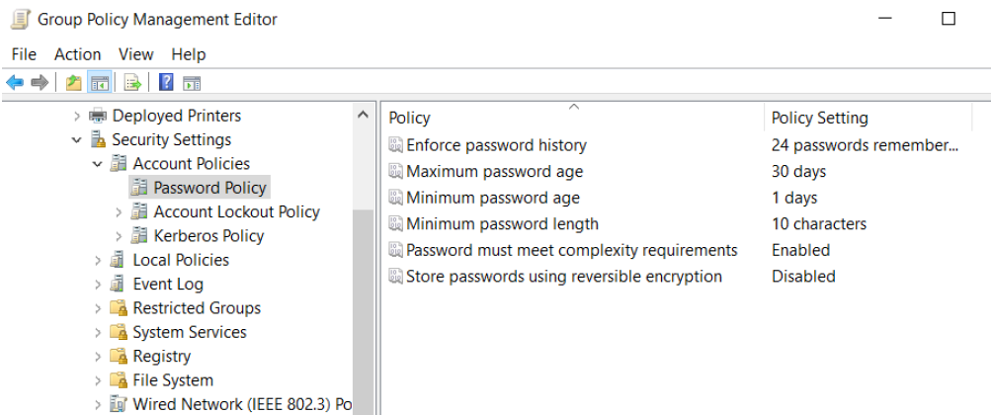

12. Configure the setting for EVERYONE in the domain such that the account is locked out after 5 failed login attempts. The lockout duration and reset duration is 30 minutes (default).

[Practical 6A - minus the template; direct configuration]

Use Group Policy Management tool to show the settings.

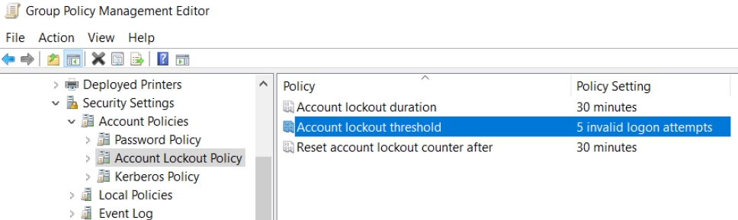

- End of Paper -

